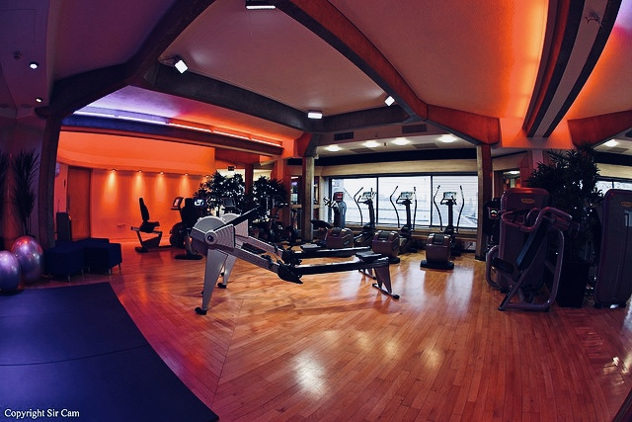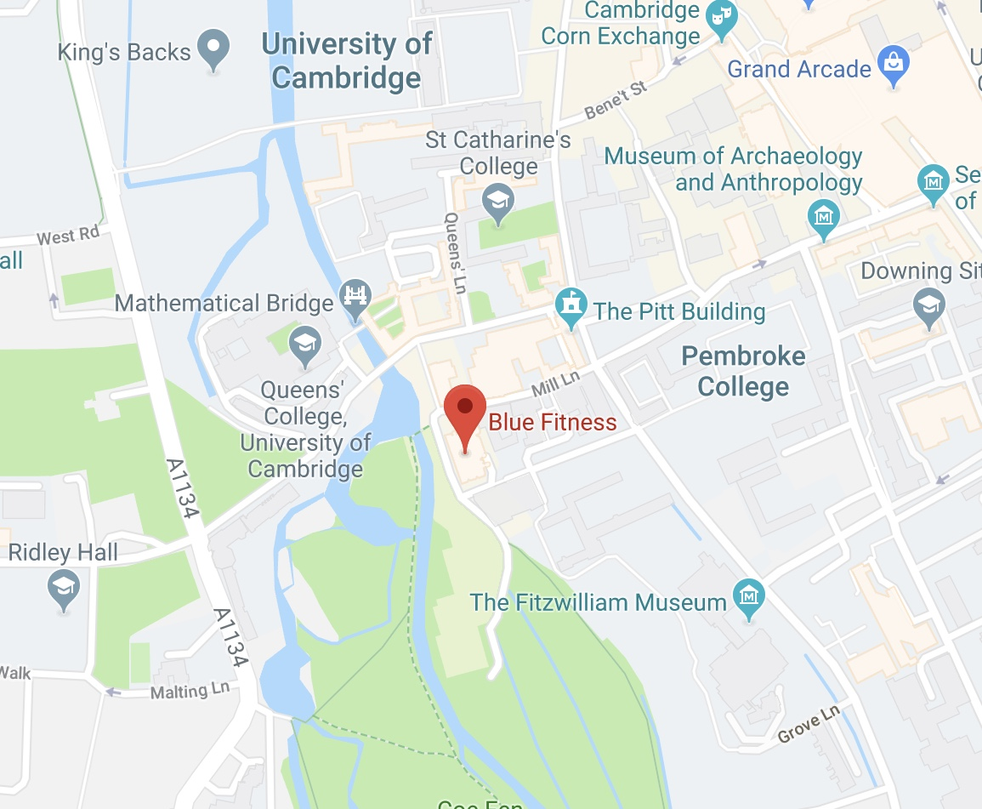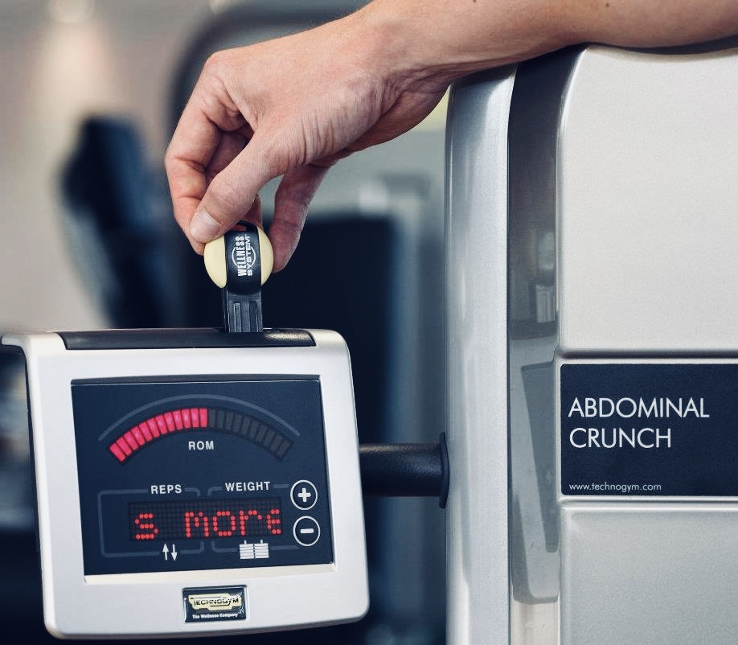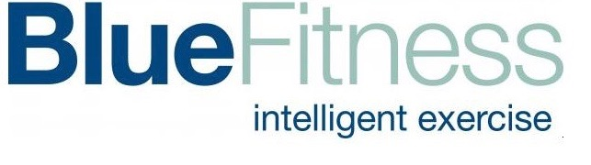

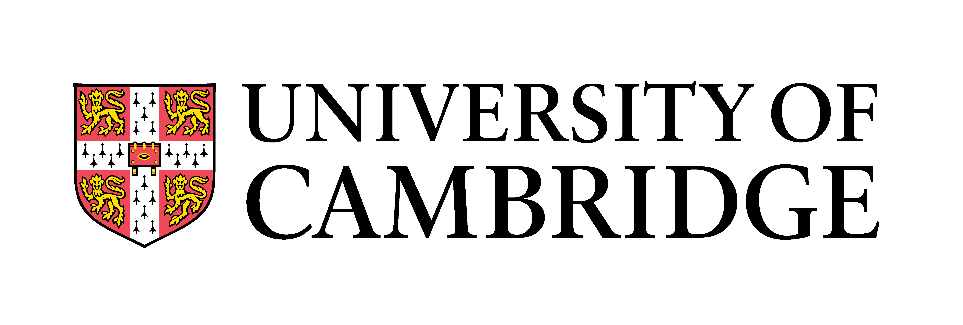

# New Year, New You!

Join today and get 14 months for the price of 12!

Interested in joining?

Simply email your enquiry to [bluefitness@admin.cam.ac.uk](mailto:bluefitness@admin.cam.ac.uk)

Offer expires on 28th February 2019