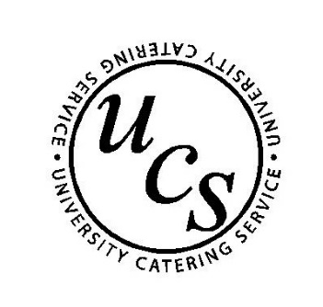
The University Catering Service Allergen Policy
March 2022
We view the issue of food allergies very seriously and have always endeavoured to ensure our students, staff and customers with special dietary requirements are well catered for with foods that are safe for them to eat. In line with the EU Food Information for Consumers Regulation (No.1169/2011) we have introduced additional controls. The Catering Manager and Senior Chef are responsible for the implementation of this policy in their respective areas of responsibility.
Training
All members of the catering team undergo classroom based Food Safety and Allergen Awareness training with MAS Environmental which is backed up with regular 'update' briefings, meeting and on-site training. The food service team are also encouraged to ask the Chefs about the foods and before service the Chefs go through the menu with the Unit Manager / Team Leader.
We use the services of MAS Environmental who will advise the catering team of any changes in legislation so these can be incorporated into this policy and the team trained accordingly. The Catering Manager and Senior Chef keep themselves up to date by getting updates from the Foods Standards Agency website. Regular refresher training is also provided to all members of the catering team.
General
Suppliers
All foods are sourced from reputable suppliers using Catering Managers Committee / The University Catering Organisation contracts and therefore all supplies will be correctly labelled in accordance with current legislation. Suppliers are required to notify us if there has been a change of ingredients so we can amend the recipe cards and allergen matrix.
Storage
In addition to correct food safety storage, bags of nuts are placed into airtight, washable containers to reduce the risk of cross contamination. These containers have red lids to further highlight the issue of the need for extra controls.

Preparation
Chefs will follow recipe cards, which list all ingredients. Where an item contains one of the designated (currently 14) allergens the Chef preparing the food will include this on the allergen chart for that dish.
Reinforcement of the awareness is provided by posters in the Kitchen reminding the team to be allergen aware.
West Cambridge Hub Canteen / University Cafes
Prior to service the Chefs will discuss the dishes with Unit Manager / Team Leader / serving staff to highlight the various ingredients and ensure the allergen information matrix is available and correct in the allergen folder.
- The daily menu with the allergen matrix will be kept in the folder so they are readily available.
- The policy statement will be displayed asking customers with dietary requirements to discuss these with serving staff.
- All members of the catering team are trained to contact the Unit Manager / Team Leader where there is any doubt or cause for concern.
Hospitality Bookings
Booking
The Hospitality Services Administrator receiving the booking will send out a request for the organiser to highlight any special dietary needs on the booking form.
Receipt of booking Form
Upon receipt of the booking form any specials diets etc to be highlighted on a checklist, which will be added to the function sheet for that event. Food will be prepared in line with the controls stated above and any special diets i.e. gluten free will be wrapped separately and labelled accordingly.
Food Delivery when served by team members
All food is labelled on our headed card for each individual diet and placed with the food. Any special dietary platters to be kept segregated wrapped and served separately to ensure no cross contamination
Food Delivery when left for client
All food is labelled on our headed card for each individual diet and placed with the food. Any special dietary platters to be kept segregated wrapped and served separately to ensure no cross contamination. The Allergen Matrix is available on the University Centre Website for clients to view and download.
Nick White
Head of University Catering

